Physics 20 Lesson 1 to 9 Review

1. A jetliner, travelling northward, is landing with a speed of 69 m/s. Once the jet touches down, it has 750 m of runway in which to reduce its speed to 6.1 m/s. Compute the acceleration of the plane during landing. (-3.1 m/s²)

2. A truck, travelling at a velocity of 33 m/s due east, comes to a halt by decelerating at 11 m/s². How far does the truck travel in the process of stopping? (+50 m)

3. A baseball is thrown upward with an initial speed of 35.0 m/s. What is its velocity at 2.00 s? (15.4 m/s up)

4. An arrow is fired straight upward with an initial speed of 15 m/s. How long is the arrow in the air before it strikes the ground? (3.1 s)

5. A golf ball rebounds from the floor and travels straight upward with a speed of 5.0 m/s. To what maximum height does the ball rise? (1.3 m)

6. A rifle bullet is shot vertically upward. Twenty-three seconds later the bullet has a velocity of 72.0 m/s, downward. What is the velocity of the bullet when the bullet leaves the rifle? (154 m/s up)

7. With what initial speed must an arrow be fired straight upward to attain a height of 110 m? (47 m/s)

8. Suppose a ball is thrown vertically upward. Eight seconds later it returns to its point of release. What is the initial velocity of the ball? (39.2 m/s up)

9. A diver springs upward with an initial speed of 1.8 m/s from a 3.0 m board. (a) Find the velocity with which the diver strikes the water. (b) What is the highest point the diver reaches above the water? (7.9 m/s down, 3.2 m)

10. Suppose a car is travelling at 12.0 m/s, and the driver sees a traffic light turn red. After 0.510 s has elapsed (the reaction time), the driver applies the bakes, and the car decelerates at 6.20 m/s². What is the stopping distance of the car, as measured from the point where the driver first notices the red light? (17.7 m)

11. A drag racer, starting from rest, speeds up for 402 m with an acceleration of +17.0 m/s². A parachute then opens, slowing the car down with an acceleration of -6.10 m/s². How fast is the racer moving 3.50 x 10² m after the parachute opens? (96.9 m/s)

*12. A rocket is launched from rest with an acceleration of 20.0 m/s², upward. At an altitude of 415 m the engines are turned off, but the rocket continues to coast upward. Find the total time that the rocket is in the air, from lift-off until it strikes the ground. (35.6 s)

**13. A spelunker (cave explorer) drops a stone from rest into a hole. The speed of sound is 343 m/s in air, and the sound of the stone striking the bottom is heard 1.50 s after the stone is dropped. How deep is the hole? (10.6 m)

14. Four-tenths of a second after bouncing on a trampoline, a gymnast is moving upward with a speed of 6.0 m/s. To what height above the trampoline does the gymnast rise before falling back down? (5.0 m)
15. A life-preserver is thrown vertically upward from a rescue helicopter that is hovering 30.0 m above the ground. The initial velocity of the preserver is 20.0 m/s.
a) Calculate the velocity with which the object strikes the ground. (31.4 m/s down)
b) Calculate the time it took for the object to reach the ground. (5.24 s)

16. An object is thrown vertically upward. If this object takes 5.30 s to go up and down, what height did it reach? (34.4 m)

17. While on planet Z, a hammer is thrown vertically upward with an initial velocity of 5.0 m/s. If the object returns to the point of release in 3.0 s, what is the acceleration of a freely falling object on this planet? (3.3 m/s²)

*18. A model rocket is launched vertically upward from the ground. After 4.3 seconds, its fuel is completely burned. Assume uniform acceleration of 3.00 m/s² while the fuel is burning.
a) What is the rocket's velocity the instant the fuel is completely burned? (12.9 m/s up)
b) What is the rocket's maximum displacement (maximum height reached) during its motion? (Remember it will continue to rise after the fuel is burned.) (36.2 m)

19. An object is rolled up an incline. If the object is 2.75 m up the incline after 4.50 s and rolling back down at a velocity of 1.90 m/s, what is the acceleration of the object? (1.12 m/s² down)

20. A rock is thrown upward at an initial velocity of 35.0 m/s upward.
a) What is the displacement of the rock during its 2nd second of motion? (+20.3 m)
b) What is the displacement of the rock during its 5th second of motion? (-9.15 m)

Multiple Choice Section

1. What is a vector quantity?

a) a quantity that is at rest
- a quantity that has a magnitude, unit, and direction
c) a quantity that explains why objects are in motion
d) a quantity that has only a magnitude and a unit

2. What is the displacement of a cyclist who starts at highway marker +3 km and ends at marker -7 km. Consider positive numbers as representing positions east of the centre of town.

a) 10 km [W]
b) 10 km [E]
c) 4 km [W]
d) 4 km [E]

3. What is the distance travelled by a jogger who starts at highway marker + 1 km, jogs to -5 km, and then proceeds to marker +8 km?

a) 4 km
b) 7 km
c) 13 km
d) 19 km
4. What does a straight line on a graph of position versus time tell us about the motion of an object?

a) The object is travelling with positive velocity.
b) The object is travelling with negative velocity.
c) The object is travelling with uniform velocity.
d) The object is travelling with zero velocity.

5. How is average speed calculated?

a) Average speed equals total distance divided by the change in time.
b) Average speed equals total distance multiplied by the change in time.
c) Average speed equals total displacement divided by the change in time.
d) Average speed equals total displacement multiplied by the change in time.

6. How can you find the velocity at any given point on a curve of a position-time graph?

a) Find the slope of the tangent to the curve at a given point.
b) Find the length of the tangent to the curve at a given point.
c) Find the slope of the straight line that joins the given point and the origin.
d) Find the length of the straight line that joins the given point and the origin.

7. What is acceleration?

a) an increase in velocity
b) a decrease in velocity
c) a change in the direction of the velocity
d) any change in velocity

8. On a velocity-time graph, what does a straight sloped line always represent?

a) constant displacement
b) constant velocity
c) uniform acceleration
d) constant speed

9. How do you find the displacement of a moving object from a velocity-time graph?

a) Find the slope of each straight line of the graph and add them together.
b) Find the length of each straight line and add them together.
c) Find the area under the graph.
d) Find the product of the slope of each line and the area under the graph.

10. A cyclist accelerates uniformly from rest to 5.0 m/s in 5.0 s. Describe the straight line representing the motion of the cyclist on a velocity-time graph.

a) The line is horizontal from 5.0 m/s at 0 s and extends to 5.0 m/s at 5.0 s
b) The line is descending from 5.0 m/s at 0 s to 0 m/s at 5.0 s
c) The line is rising from 0 m/s at 0 s to 5.0 m/s at 5.0 s
d) The line is vertical from 0 m/s at 5.0 s to 5.0 m/s at 5.0 s

Multiple Choice Answers

1. B
2. A
3. D
4. C
5. A
6. A
7. D
8. C
9. C
10. C
Graphical Analysis

1. The following position-time graph represents the motion of a steel ball rolling up an incline, coming to a stop, and returning back to its original position.
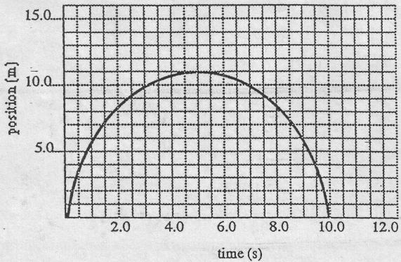
Calculate the velocity at
a) 3.0s
b) 5.0 s
c) 7.0 s

2. Given the following velocity-time graph for an object moving along a line,
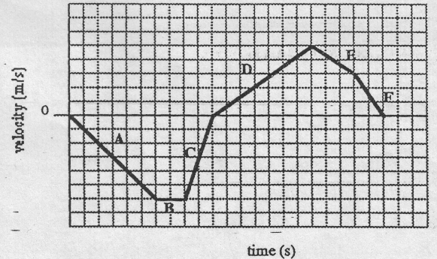
In which section(s) is the
a) displacement greatest?
b) velocity the greatest?
c) displacement positive?
d) displacement negative?
e) velocity positive?
f) velocity negative?
3. Given the following position-time graph for an object moving along a straight line, find the
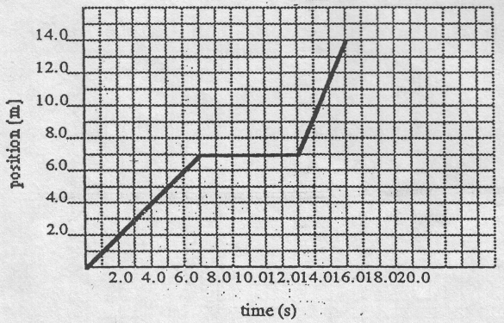

a) displacement of the object at 16.0 s
b) velocity at 5.0 s
c) velocity at 9.0 s
d) velocity at 15:0 s
e) average velocity of the motion described
f) acceleration : between 2-0 s and 6.0-s

4. Given the following velocity-time graph for an object moving along a line,

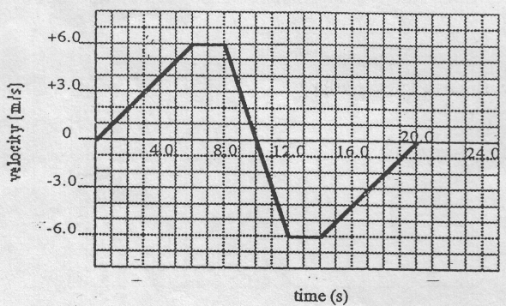
find the
a) velocity at 4.0 s
b) velocity at 7.0 s
c) velocity at 11.0 s
d) acceleration at 10.0 s
e) acceleration at 17.0 s
f) displacement at 10.0 s
g) average velocity during the total motion described

5. Given the following position-time graph for an object moving along a line,
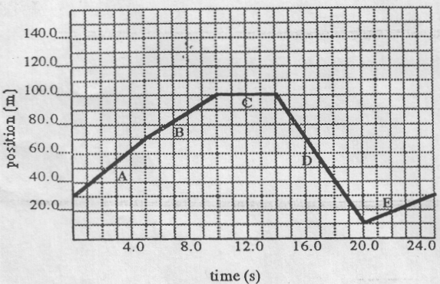
a) find
i) the velocity of the object at 17.0 s
ii) the total distance travelled by the object from the beginning to the end of the motion described in the graph
iii) the displacement of the object from the beginning to the end of the motion described in the graph
iv) the average speed of the object during the motion described in the graph.
b) during which time interval
i) does the object have a negative displacement?
ii) does the object have a negative velocity?
iii) does the object reach its highest velocity?

6. Given the following position-time graphs,
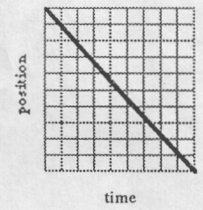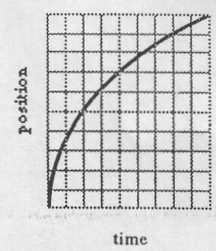

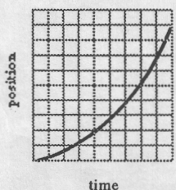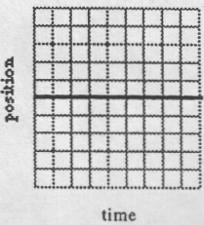
Which of these graphs represents:
a) zero velocity?
b) motion in which the velocity is increasing?
c) motion in which the velocity is decreasing?
d) motion in which the velocity is constant?
Graphical analysis answers

1. a) v = +1.0 m/s
b) v = 0
c) v = –1.0 m/s

2. a) A
b) B
c) D, E, F
d) A, B, C
e) D, E, F
f) A, B, C

3. a) d = 14.0 m
b) v = +1.0 m/s
c) v = 0
d) v = 2.3 m/s
e) v = 0.875 m/s
f) a=0

4. a) v = +4 m/s
b) v = +6 m/s
c) v = –3 m/s
d) a = –3.0 m/s²
e) a = +1.0 m/s²
fl d= + 36m
g) v_{av} = 0

5. a)
i) v = –15 m/s
ii) d = 180 m
iii) d = 0
iv) v_{av} = 7.2 m/s

b)
i) E
ii) D
iii) D

6. d c

b a

